Date:16/04 /24
A.Y 2023-24(Even Sem)

Report on PSR Activity: Super AI Community Stakeholder Connect

Objective:
The objective of Super AI Community Stakeholder Connect is to empower students for success in Artificial Intelligence (AI) and their future careers by building a strong foundation in AI fundamentals, providing them with Workshops on R programming and Generative AI, Sharpening problem-solving and coding skills through dedicated sessions or participation in online challenges, and guidance helped students craft compelling LinkedIn profiles to showcase their AI skills and experience to potential employers.

Following activities are done during Academic Year 2023-24 Even Semester:

Activity 1: Expert Session on Sectors Exploration and Multicon Paper Presentation

Date: January 20, 2024
Time: 3:00 PM - 5:00 PM(Online)
Speaker: Dr. Megharani Patil, HOD-AI&ML, Sector in-charges

Participants: ST

Objectives:
- Broaden student understanding of the diverse applications of AI/ML across different sectors.
- Spark their interest in exploring specific areas of AI/ML specialization.
- Equip them with the knowledge and skills necessary to create compelling poster papers for academic conferences like MulticonW24.

Description:

Super AI Stakeholder Connect is organizing an online session, offering an orientation for students interested in the diverse applications of Artificial Intelligence and Machine Learning (AI/ML). The session also provides guidance on crafting poster papers for the MulticonW24 conference.

Participation Analysis:

Sr. No. | Class | No. of Students
1 | ST | 44
Total: |  | 44

Feedback Analysis:

Outcome:
- Participants gained a broader understanding of the diverse applications of AI/ML across different sectors.
- The session potentially sparked their interest in pursuing specific areas of AI/ML specialization.
- Students acquired knowledge and skills necessary for crafting impactful poster papers, potentially leading to conference presentations or research opportunities.

PO Attained: PO1,PO2, PO4,PO8,PO9, PO10

Activity 2: Gate Mock Test

Date: 2nd February 2024

Time: 2:00PM to 5:00PM(Online)

Participants: ST, TT and BT Students

Objectives:
The mock test aimed to:
- Provide students appearing for the GATE exam with a realistic simulated testing experience.
- Help them assess their current level of knowledge and identify areas requiring further revision.
- Facilitate time management practice under exam conditions (3-hour duration).
- Allow students to familiarize themselves with the GATE exam format and question styles.

Description:

Super AI Community Stakeholder Connect is conducting a Mock Test for all the students who

are going to appear for the GATE Examination, Data Science and AI subjects. Everyone is requested to give the exam as a practice, even if they are not appearing for GATE now
Activity Photo:

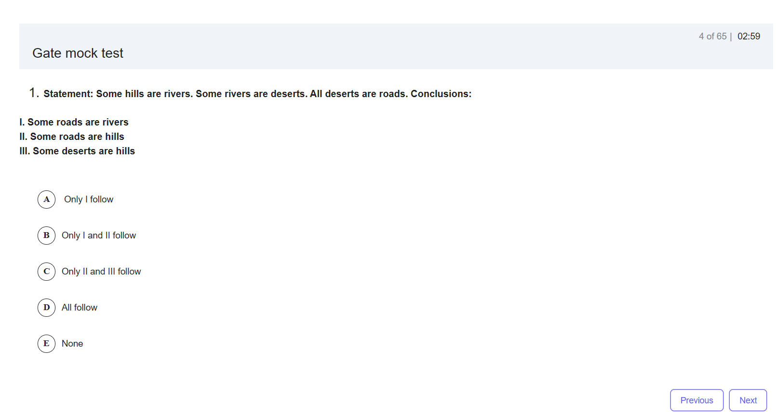Participation Analysis:

Sr. No. | Class | No. of Students
1 | ST | 06
2 | TT | 03
3 | BT | 01
Total : |  | 10

Feedback Analysis:

Outcome:

Participants gained insights into their current level of knowledge and preparedness for the GATE exam in Data Science and AI. This allows them to show areas requiring more focus in their studies. Taking the mock test under timed conditions (3 hours) simulates the actual GATE exam experience. This helps students practice managing their time effectively and develop their exam-taking strategies.

PO Attained: PO1,PO2, PO3, PO4,PO5, PO6,PO8,PO9

Activity 3: Expert Session on BAI:Intelligent Systems Foundation to recent trends

Date – 3rd Feb 2024

Time - 11:30 to 1.30 PM(Online)
Speaker: Dr. Megharani Patil, HOD-AI&ML

Participants: ST students
Objectives:
The session aimed to:

To provide participants with a comprehensive understanding of the foundational concepts of intelligent systems and their application in business contexts, leading up to the exploration of recent trends in Business AI.

Description:
Super AI Community Stakeholder Connect conducted an expert session on Basics of Artificial Intelligence presented by Dr.Megharani Patil This session aims to provide participants with a holistic view of Business AI, from its foundational concepts to the latest trends and future prospects, thereby enabling them to make informed decisions and strategies in leveraging AI for business growth and innovation.
Participation Analysis:

Sr. No. | Class | No. of Students
1 | ST | 48
Total : |  | 48

Feedback Analysis:

Outcome:
Participants gained a deeper understanding of how AI technologies are transforming various sectors through research and report writing. The collaborative task likely fostered teamwork and communication skills. The session potentially sparked further interest in exploring specific AI applications within different industries.

PO Attained:PO1, PO2, PO3, PO4,PO5

Activity 4: Peer Session on Competitive Programming

Date – 3rd February,2024

Time – 5:00pm to 7:00PM(Online)
Speaker: Mr.Rohit Gupta,BT AI&ML student

Participants: ST, TT, BT Students

Objectives:
- Spark student interest in the exciting world of competitive programming.
- Demystify the core concepts and benefits of participating in coding challenges.
- Equip beginners with foundational knowledge of data structures and algorithms relevant to competitive programming.

Description:

Super AI Community Stakeholder Connect is conducting a Competitive Programming session to learn more about competitive programming and data structures and algorithms. Providing valuable insights and resources for beginners interested in pursuing competitive programming.

Participation Analysis:

Sr. No. | Class | No. of Students
1 | ST | 30
2 | TT | 18
3 | BT | 02
Total : |  | 50

Activity Photo:
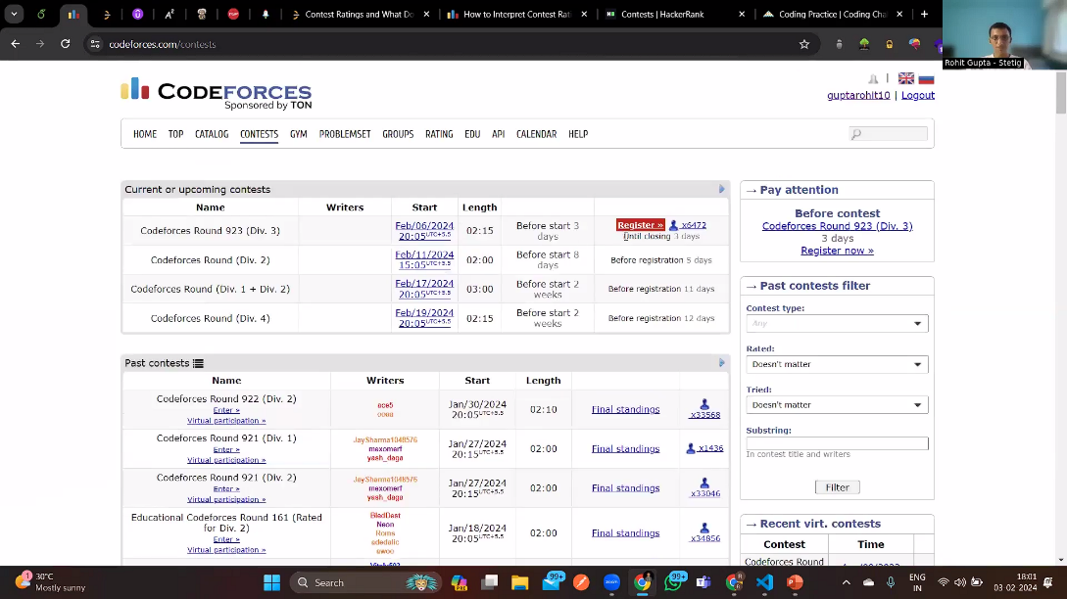

Feedback Analysis:

Outcome:
Participants gained a solid understanding of what competitive programming entails and the key elements involved. The session piqued the curiosity of students who may not have been familiar with competitive programming, potentially motivating them to explore it further. Participants gained practical insights and resources to begin their journey in competitive programming, potentially leading them to practice basic problem-solving challenges.
PO Attained:PO1, PO2, PO3,PO4,PO5, PO9,PO12

Activity 5: Expert Session On SE(UML)

Date – 9th February,2024

Time – 10:30pm to 12:30PM,Offline 722
Speaker: Dr. Megharani Patil, HOD-AI&ML

Participants: TT Students

Objectives:
The session aimed to:
- Introduce participants to StarUML, a popular UML diagramming tool.
- Provide a basic understanding of UML concepts and their role in software development.
- Equip participants with the foundational skills to create basic UML diagrams using StarUML.

Description:

This online session, organized by Super AI Community Stakeholder Connect, offered an introduction to StarUML, a software application used for creating UML (Unified Modeling Language) diagrams. UML diagrams are a visual representation of software systems, used for designing, documenting, and visualizing software components and their interactions.

Participation Analysis:

Sr. No. | Class | No. of Students
1 | TT | 32
Total : |  | 32

Feedback Analysis:

Outcome:
Participants gained a foundational understanding of UML diagrams and their significance in software development. They were introduced to the StarUML interface and its basic functionalities for creating UML diagrams. The session potentially sparked an interest in exploring UML diagramming further and learning more advanced features of StarUML.

PO Attained:PO1, PO2, PO3,PO4,PO5

Activity 6: Expert Session on BAI: Intelligent Agents Applications

Date – 17th February,2024

Time – 10:30pm to 12:30PM(Online)
Speaker: Dr. Megharani Patil, HOD-AI&ML

Participants: ST Students

Objectives:
The session aimed to:
- To explore the diverse applications of intelligent agents in BAI) providing insights into how these agents enhance efficiency, decision-making, and customer experience across various industries.

Description:

This expert session delves into the multifaceted applications of intelligent agents within Business AI (BAI). It illuminates how these agents, powered by advanced technologies like machine learning and natural language processing, revolutionize customer service, sales, operations, finance, and healthcare. Through case studies and discussions, participants explore the transformative impact of intelligent agents on efficiency, decision-making, and customer experience across diverse industries, while also addressing key challenges and future opportunities in their implementation.

Outcome:
Participants have identified and discussed various applications of intelligent agents in business, academia, or other sectors

Participation Analysis:

Sr. No. | Class | No. of Students
1 | ST | 47
Total : |  | 47

PO Attained:PO1, PO2, PO3,PO4,PO5

Activity 7: Expert Session on Major Project
- Date: 14th March 2024
- Time: 3:00 PM - 5:00 PM
- Location: Offline (Room 721)
- Speaker: Dr. Megharani Patil, HOD-AI&ML
Objective:
The workshop aimed to:
- Equip students with the knowledge and skills necessary to write a comprehensive and well-structured Black Book for their Major Projects in Artificial Intelligence and Machine Learning (AI/ML).
- Enhance their understanding of the purpose and content of a Black Book, which serves as a detailed record of the entire project lifecycle.
- Provide practical guidance on effectively documenting project details, including problem definition, methodology, results, discussion, and conclusions.
- Foster best practices for clear, concise, and well-organized technical writing within the Black Book.

Description:
This offline workshop, organized by Super AI Community Stakeholder Connect, focused on guiding final-year students through the process of drafting a Black Book for their Major Projects. Dr. Megharani Patil, HOD-AI&ML, led the session.

Participation Analysis:

Sr. No. | Class | No. of Students
1 | BT | 23
Total : |  | 23

Feedback Analysis:

Outcomes:
Participants gained valuable insights into the structure and key components of a well-written Black Book. The workshop equipped students with practical strategies for documenting their research methodologies, project steps, and findings within the Black Book. By understanding best practices for technical writing, students were empowered to present their project effectively through the Black Book. The session potentially boosted confidence in approaching the Black Book writing process with a clear roadmap.

PO Attained:PO1, PO2, PO3,PO4,PO5,PO7,PO8,PO9,PO10,PO11,PO12
Activity 8: Coding Competition.

Date - 15th March, 2023

Time – 8:00PM to 10:00 PM(Online)

Participants: ST, TT, BT Students

Objectives:

Provide participants with an opportunity to enhance their coding and problem-solving skills.

Foster a spirit of healthy competition to motivate participants to excel in coding challenges.

Promote community engagement and collaboration through a coding competition.

Description:

Super AI Community Stakeholder Connect is excited to host a Coding Competition, offering participants a platform to enhance their coding and problem-solving skills. The competition is designed to challenge participants with a series of coding problems that span various difficulty levels, providing a comprehensive learning experience.

Activity Photo:
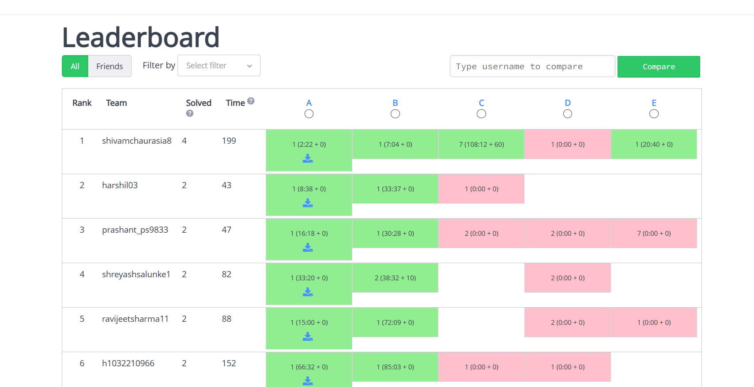

Participation Analysis:

Sr. No. | Class | No. of Students
1 | ST | 14
2 | TT | 10
3 | BT | 01
Total : |  | 25

Feedback Analysis:

Outcome:
Students were able to enhance their problem-solving abilities and cognitive reasoning skills through active participation in the Quiz competition.
PO Attained: PO1, PO2, PO8, PO9,PO12

Activity 9: Expert Session on topic of R Programming and Generative AI:Hands-On Workshop on “From Data Science to Creative Intelligence”

Date – 29th March 2024 and 30th March 2024

Time – 12:00noon -3:00pm,3:30pm-6:30pm and 12:00pm-4:00pm(Online)
Speaker: Mr. Yadnesh Mohan Zagade, CEO & Founder, Tech Cryptors, Alumni of Computer Engineering Department

Participants: ST, TT, BT Students
Objectives: The event aimed to equip students with valuable skills and knowledge in data science and generative AI:
- Provide a foundation in R programming, a popular tool for data analysis across various fields.
- Introduce participants to advanced R techniques used in data science workflows.
- Deepen understanding of generative AI concepts through a workshop featuring real-world case studies.

Description:

Super AI Community Stakeholder Connect is excited to host two-day online event, featuring expert lectures on R Programming and Generative AI, delivered by Mr. Yadnesh Mohan Zagade, CEO & Founder of Tech Cryptors.

Participation Analysis:
Day 1:
Sr. No. | Class | No. of Students
1 | ST | 24
2 | TT | 21
3 | BT | 10
Total : |  | 55

Day2:
Sr. No. | Class | No. of Students
1 | ST | 12
2 | TT | 10
3 | BT | 23
Total : |  | 45

Activity Photo:
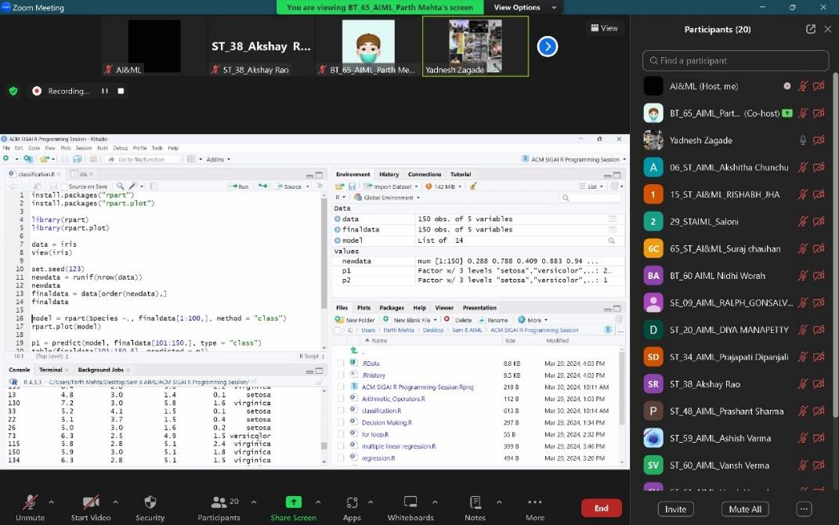

Feedback Analysis:

Outcome:
- Participants gained an introduction to R programming and its applications in data analysis.
- The advanced R programming session equipped them with additional skills for data science tasks.
- The generative AI workshop provided insights into this evolving field with practical examples.

PO Attained:PO1, PO2, PO3, PO4,PO5,PO9,PO10

Activity 10: Expert Session on Case studies on Cognitive Computing Hybrid Systems in Soft Computing and Linkedin Profile Building
Date: 5th April 2024 and 6th April 2024
Time: 2:00pm-5:00pm (Online)
Speaker: Mr. Salmon Joy, Accennovate Tech Solutions
Participants: TT students
Objective:
The session aimed to:
- Enhance student knowledge and understanding of advanced AI concepts.
- Provide practical insights into the applications of Cognitive Computing and Hybrid Systems through case studies.
- Foster student engagement with the evolving field of AI.

Description:
Mr. Joy's session explored the exciting world of AI through real-world applications, focusing on two key areas:
- Case Studies on Cognitive Computing: This segment likely showcased examples of how systems mimic human-like cognitive abilities for tasks like learning, problem-solving, and decision-making.
- Hybrid Systems in Soft Computing: The presentation potentially delved into the concept of combining techniques like fuzzy logic, neural networks, and evolutionary algorithms with traditional computing methods to address complex challenges.

Participation Analysis:
Sr. No. | Class | No. of Students
1 | TT | 51
Total: |  | 51

Activity Photo:
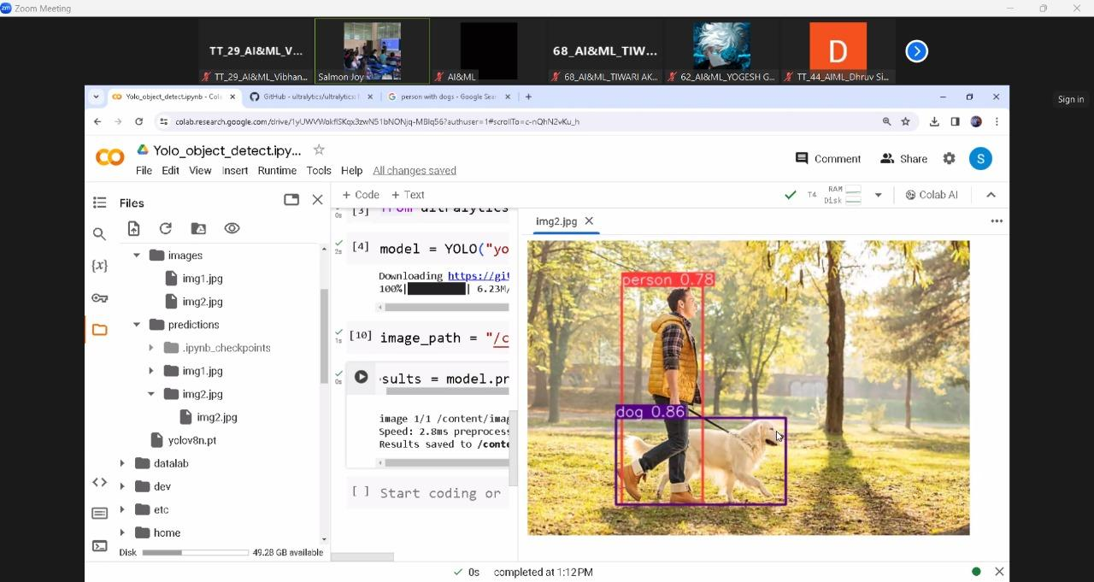

Feedback Analysis:

Outcome:
- Participants gained valuable knowledge about the capabilities and applications of AI.
- The session exposed them to real-world examples of Cognitive Computing and Hybrid Systems in action.
- The interactive format (potentially including Q&A or discussions) likely fostered deeper understanding and engagement with the presented topics.

PO Attained:PO1, PO2, PO3, PO4,PO5,PO9,PO10

LinkedIn Profile Building

Date: April 6th, 2024

Time:10:00am-2:00pm(Online)

Speaker: Mr. Madhur Sharma, Founder & CMO, Kalaa Creations

Participants: ST, TT and BT students

Objectives:

The workshop aimed to empower students to develop a strong online presence that enhances their professional brand and career prospects. Participation offered AICTE credits, further incentivizing student participation.
- Learn strategies for crafting a strong profile that showcases their skills, experience, and career goals.
- Gain insights into optimizing their profile for searchability by potential employers and industry professionals.
- Discover techniques for building a valuable network and connecting with professionals within their field.

Description:

Super AI Stakeholder Connect's workshop led by Mr. Madhur Sharma, equipped participants with the knowledge and skills necessary to build a compelling and effective LinkedIn profile.

Participation Analysis:
Sr. No. | Class | No. of Students
1 | ST | 41
2 | TT | 11
3 | BT | 02
Total: |  | 54

Activity Photo:
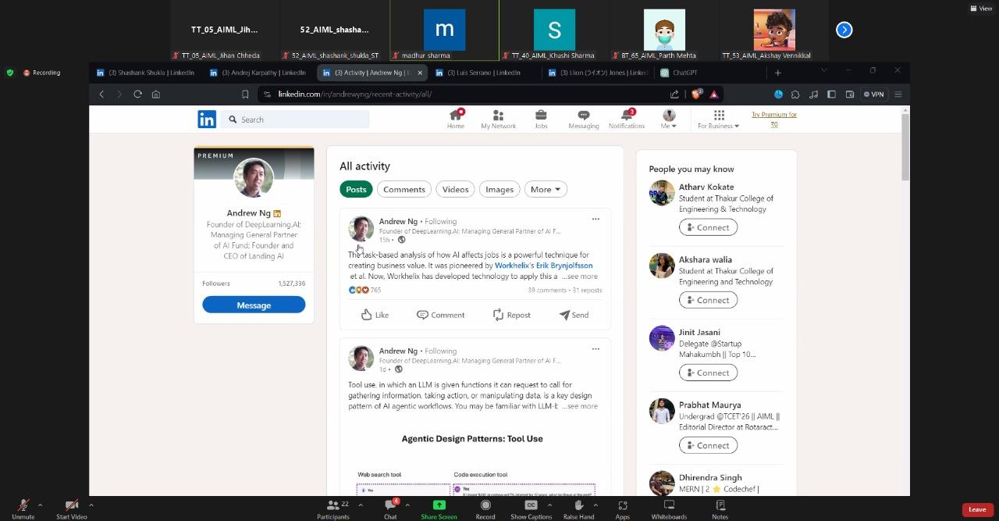

Feedback Analysis:

Outcome:
Participants acquired valuable skills and knowledge for building a powerful LinkedIn profile that effectively showcases their qualifications. The workshop equipped them with strategies for online networking and professional development through LinkedIn. By attending, students gained an advantage in the job market by creating a strong online presence that attracts potential employers.

PO Attained: PO5, PO7, PO8,PO9,PO10,PO12

Prepared By
Mrs Shilpa Mathur Dr.Megharani Patil
Faculty Coordinator Convener
Assistant Professor AI&ML HOD AI&ML

